Test Report – CT_PR-Head-IMG_GSPS

Revision
Date | Author | Test Suite / Test Report | Description / Test Instance link
September 10th 2021 | Gigi Lamoroso | Test Suite | Initial version of the test suite
October 5th 2021 | Paule Hochon | Test Report | Initial version of the test report.  Permanent link of the test instance in Gazelle  https://sharazone.ihe-europe.net/gazelle/testing/test/test/TestInstance.seam?id=8&cid=33267

Purpose
This is to evaluate a new GSPS implementation, especially the various markups display and window level / VOI LUT sequence.

Products identification

Creator product
MYBRAND Healthcare - CT Ambition - version 3.0

Consumer product
OURBRAND Imaging – PACS Romana – version 2.1

Test Input: CT_PR-Head-IMG_GSPS
Permanent link to the test input in Gazelle: https://sharazone.ihe-europe.net/gazelle/objects/sample.seam?id=7
It contains one Series of CT head images and one GSPS series. several markups were saved in the presentation state as well as modified W/L. The PR contains also a VOI LUT sequence.

Shared test input structure:
Patient ID | Study IUID | Series IUID | Number of instances  or file names | Description | SOP Class UID(s)
123 | 1.2.3.51.78.2344.1 | 1.2.3.51.78.2344.1.1 | 348 images | CT head series | 1.2.840.10008.5.1.4.1.1.2
 |  | 1.2.3.51.78.2344.1.2 | GSPS.dcm | GSPS series | 1.2.840.10008.5.1.4.1.1.11.1

Test Script
Step | Action | Expected Result | Actual Result | Status

Import
#1 | Import Test Items into Consumer application | Test items can be imported (SOP classes / Transfer syntaxes are supported by the Consumer application).  if one of the SOP class / Transfer syntax is not supported by your application, mention it in Actual Result. Provide a link to your DCS | All objects were properly imported using Explicit Little Endian Transfer syntax | Pass
#2 | Check the Study/series/instances hierarchy in the consumer application | Study, Series, instances hierarchy is as described in the “Test Input structure table” | The study list screen of our application shows the proper number of series (2) and images / instances in the study | Pass
#3 | Navigate through the test input in the consumer application | Next/previous image/frame/series navigation behaves correctly within the Consumer application | Navigation through the series properly handled | Pass

Image display
#10 | Thumbnail view into the Consumer display | Thumbnails are representative of the image content and displayed default window/level values | There is no possibility to display the thumbnails in our application | N/A
#11 | Grayscale image view into the Consumer display. Do not apply the Presentation state | Grayscale images display VOI LUT or window values supplied in the DICOM header of the images.  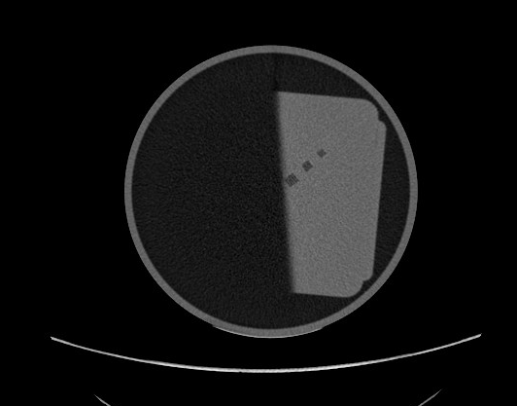 | Grayscale Images properly displayed when GSPS is not applied: | Pass
#12 | Grayscale image view into the Consumer display. Apply the Presentation state and check the grayscale | Grayscale images display VOI LUT or window values supplied in the DICOM header of the GSPS.  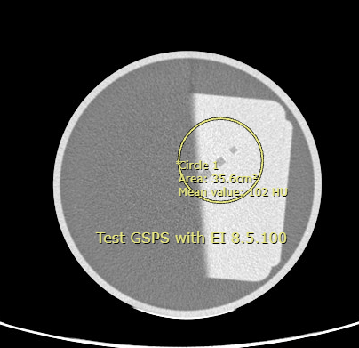 | Images are much too bright. Something is wrong with the interpretation of the W/L or the VOI LUT sequence present in the GSPS  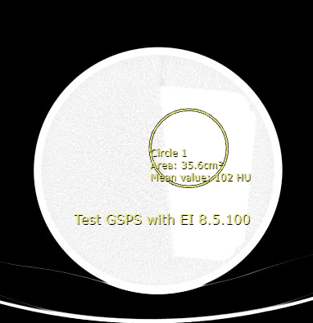 | Fail
#13 | Markups and annotations view into the Consumer display. Apply the presentation state and scroll to image N° 5 on which the markups and annotations are applied | Markups and annotations present in the GSPS for image N°5 are properly applied by the consumer viewer.  See screen shot of expected result in step #12 | Markups and annotations properly displayed. See screen shot previous step | Pass

Overall Comments

Storage / display of images worked as expected.
- GSPS is properly applied for markups and annotations, However for the grayscale, images are too bright. We’d like to discuss encoding of the Softcopy VOI LUT sequence in the GSPS object.

